

**LAB Report**

**COURSE TITLE –** Microprocessor Lab

**COURSE CODE –** CSE 360

***Submitted To***

***Md. Ismail***

*Lecturer of UITS*

***Submitted By***

*Md. Shoyaif Rahman (****0432310005101050****)*

***Semester:*** *Autumn-2025 (6th)*

***Department:*** *CSE*

***Batch:*** *53*

***Section:****6A2*

Date: 03/09/25

Assembly Language Lab Report

# Lab report: 03

# Experiment Name: Write a program to print a to z and 9 to 1 using loop

# Process:

**Printing a to z:**

1. Start the program at memory location 100h.
2. Initialize the starting character: Load ASCII value 97 (letter 'a') into register BL.
3. Enter a loop to print characters continuously until 'z' is reached.
4. Print the current character stored in BL on the screen.
5. Print a space after the character for better readability.
6. Increment BL to move to the next character in the ASCII sequence.
7. Compare BL with 122 (ASCII value of 'z').
8. If BL ≤ 122, repeat the loop.
9. If BL > 122, exit the loop.
10. End the program and return control to the operating system.

**Printing 9 to 1:**

1. Start the program at memory location 100h.
2. Initialize the starting number
3. Load ASCII value 57 (corresponding to '9') into register BL.
4. Enter a loop to print numbers continuously until '1' is reached.
5. Print the current number stored in BL on the screen.
6. Print a space after the number for better readability.
7. Decrement BL to move to the previous number in the ASCII sequence.
8. Compare BL with 49 (ASCII value of '1').
9. If BL ≥ 49, repeat the loop.
10. If BL < 49, exit the loop.
11. End the program and return control to the operating system.

## 2. Implementation (Program Code – ASM)

1. **Printing a to z**

org 100h

MOV BL ,97

lOOP:

MOV AH, 2

MOV DL, BL

INT 21H

MOV DL,32

INT 21H

INC BL

CMP BL, 122

JLE LOOP

ret

**output:**

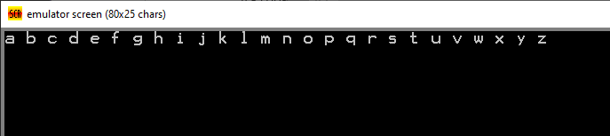

**Printing 9 to 1:**

org 100h

MOV BL ,57

lOOP:

MOV AH, 2

MOV DL, BL

INT 21H

MOV DL,32

INT 21H

DEC BL

CMP BL, 49

JGE LOOP

ret

**output:**

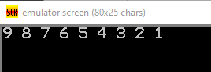

**3.Result**

The first program prints all lowercase letters from a to z, incrementing the register BL and displaying a space after each letter for readability. The second program prints numbers from 9 down to 1, decrementing BL and adding spaces between numbers. Both programs demonstrate the use of loops, ASCII values, and DOS interrupt 21h, function 2, to display characters in a controlled sequence.

## 4. Conclusion

Both programs successfully demonstrate the use of loops and ASCII values in 8086 assembly language to print sequences of characters on the screen. The first program shows how to print lowercase letters from a to z in ascending order using increment operations, while the second program illustrates printing numbers from 9 to 1 in descending order using decrement operations. These programs highlight the use of DOS interrupt 21h, function 2, for character output, and reinforce the concepts of loop control, ASCII manipulation, and sequential printing in assembly programming.